Do following steps in node.js cmd prompt.

Your environment has been set up for using Node.js 10.16.0 (x64) and npm.

C:\Users\user16>F:

F:\>cd nilniknit@gmail.com

F:\nilniknit@gmail.com>cd Angular_RETEST

The system cannot find the path specified.

F:\nilniknit@gmail.com>cd AngularRETEST

F:\nilniknit@gmail.com\AngularRETEST>mkdir angularJune16

F:\nilniknit@gmail.com\AngularRETEST>**cd angularJune16**

F:\nilniknit@gmail.com\AngularRETEST\angularJune16>**ng new**

? What name would you like to use for the new workspace and initial project? **myapp**

? Would you like to add Angular routing? No

? Which stylesheet format would you like to use? (Use arrow keys)

> CSS

SCSS [ http://sass-lang.com/documentation/file.SASS_REFERENCE.html#syntax ]

? Which stylesheet format would you like to use? CSS

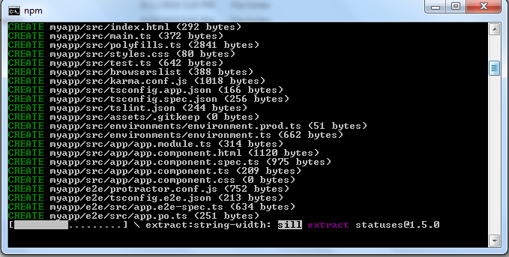

Let it complete…..

F:\nilniknit@gmail.com\AngularRETEST\angularJune16>**cd mayapp**

F:\nilniknit@gmail.com\AngularRETEST\angularJune16\myapp>**npm start**

OR

F:\nilniknit@gmail.com\AngularRETEST\angularJune16\myapp>**ng serve**

Now we will get the PORT No.4200

Go to Chrome browser .

URL : localhost:4200

**Done :)**

**Now open visual studio code editor .**

**File – Open Folder : myapp**

**Src – app – app.component.cs**

**-app.module.ts**

**-app.component.html**

**-app.component.css**

And do coding in respective folders.

1)app – new folder – food

2)food – new file – **foodlist**.component.html

3)food – new file – foodlist.component.ts

4)app – new file – foodservice.services.ts

5)add **<foodlist></ foodlist>** in app.component.ts

6)open foodservice.services.ts

export class foodservice

{

getFood()

{

return[

{Id:111,name:"Pizza",price:99},

{Id:222,name:"Veg Burger",price:49},

{Id:333,name:"Veg Nugets",price:79},

{Id:444,name:"Cheeze Balls",price:59}

]

}

}

7)foodlist.component.ts

import { Component } from '@angular/core'

import { foodservice } from './foodservice.services';

@Component

({

selector:'foodlist',

templateUrl:'./foodlist.component.html'

})

export class foodlistComponent

{

foodArray=[];

constructor(private foodservice:foodservice){}

ngOnInit()

{

this.foodArray=this.foodservice.getFood();

}

}

8)app.module.ts

import { BrowserModule } from '@angular/platform-browser';

import { NgModule } from '@angular/core';

import { AppComponent } from './app.component';

import { FormsModule } from '@angular/forms';

import { foodservice } from './FOOD/foodservice.services';

import { foodlistComponent } from './FOOD/foodlist.component';

@NgModule({

declarations: [

AppComponent,foodlistComponent

],

imports: [

BrowserModule,FormsModule

],

providers: [foodservice],

bootstrap: [AppComponent]

})

export class AppModule { }

9)app.component.html

<!--The content below is only a placeholder and can be replaced.-->

<div style="text-align:center">

<h1>

Welcome to {{ title }}

</h1>

<hr>

<img width="300" alt="food Logo" src="assets/Images/logo.jpg">

</div>

<hr>

<foodlist></foodlist>

10)assets foder : create p.html

<html>

<head>

</head>

<body>

<h3>You selected Pizza</h3>

<p>Price : 99</p>

<p>Will be delivered soon ...</p>

<p>Thank you !!</p>

</body>

</html>

11)assets – Images folder – store images